**Prevalence of Background Checks in Online Firearms Sales**

In 2015, 36,252 persons died in the United States from firearm-related injuries; another XX,000 were injured. Increased firearm deaths have been associated with lenient policies regulating gun sales (**XX**). While brick-and-mortar stores must require gun buyers to pass a background check, private sellers are not under the same federal restrictions.

Popular websites such as Armslist.com allow the sale of firearms by both private sellers and retail outlets. We assessed the number and proportion of private gun sales on Armslist.com that required a background check or other identification from the buyer before purchase (a practice we term “responsible selling”).

**Methods:** We recorded posts listed on Armslist.com between July 14th, 2008 and June 25th, 2018. To record these posts, we implemented a web scraping procedure from May 4th, 2018 to June 29th, 2018 using the Python package “Beautiful Soup”. We identified roughly **4.90** million postings related to firearms available for purchase on Armslist.com during this time period. Collected data included gun type, post title, date of post, and a description. We removed irrelevant gun and advertising categories (e.g., “paintball” and “want to buy”, respectively) from the analysis. We defined a listing as displaying responsible selling if it contained at least one of the following terms or their corresponding acronyms: Concealed carry weapon (CCW); concealed carry license (CCL); federal firearm license (FFL); or permit to purchase (P2P). We also determined descriptions to be “responsible” if they included the terms “background check,” “license,” “permit,” or “required.” Negations, such as “no background check” or “not required,” were excluded. Sample data and the complete inclusion and exclusion criteria can be found in the supplemental material.

**Results:** We identified 4,903, 770 relevant gun advertisements listed between July 14, 2008 and June 25, 2018. Of this sample 523,854 (10.68% [9.8%, 11.56%]) indicated responsible selling. The three most commonly observed gun categories observed were “handguns” (2,367,588; 47.92%), “rifles” (1,636,201; 33.13%), and “shotguns” (411,276; 8.32%). Among these categories, the proportion of posts displaying responsible selling were **48.28%, 33.37%, and 8.39**% respectively.

Of the 4,930,052 listings, **XX** did not ask for any sort of background check. Among firearms listed as “automatic weapons”, **XX** of **XX** listings did not ask for a background check. (Note: All automatic weapons require a background check - the listing in armslist was likely misspecified as a semi-automatic.) There was considerable heterogeneity in both the number of firearm listings per capita in each state and the percentage of firearm listings that do not exhibit responsible selling (Figure 1). Sensitivity analyses regarding these definitions indicated that our results are not sensitive to minor changes. These sensitivity analyses are discussed in detail in the Supplemental Material.

**Discussion**: Our findings suggest that more than four million firearms, including automatic weapons, were available for purchase without a background check throughout the United States over a ten-year period.

**Authors:**

Yang Liu, PhD1; Ashley Hernandez, MSPH2; Coleman Drake, PhD3; Adam Schwartz, PhD2; Maria Sundaram, MSPH, PhD4

**Affiliations:**

1London School of Hygiene and Tropical Medicine

2 University of Minnesota School of Public Health

3 University of Pittsburgh Graduate School of Public Health

4 Emory University Rollins School of Public Health

**Table 1**

|  |  |  |
| --- | --- | --- |
| Gun type | Number of advertisements selling this gun type | N (%) of posts displaying responsible selling |
| Handguns | **2,367,588** | **14.32** |
| Rifles | **1,636,201** | **8.80** |
| Shotguns | **411,276** | **6.95** |
| Gun | **261,189** | **2.17** |
| Tactical | **79,469** | **0.82** |
| Antique | **52,493** | **6.82** |
| Reloading | **47,624** | **0.31** |
| Muzzle | **33,057** | **2.90** |
| NFA | **8,588** | **11.35** |
| Firearms | **5,827** | **5.05** |
| Other | **347** | **2.02** |
| All | **111** | **12.61** |
| Total | **4,903,805** | **10.86** |

**Figure 1**

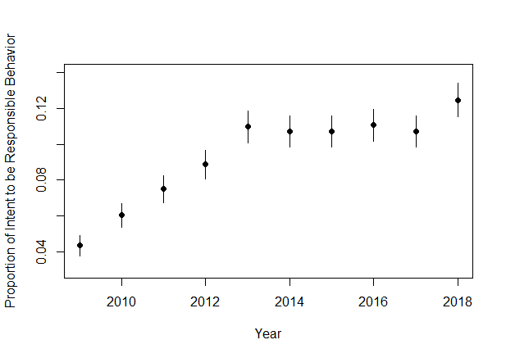

* X: Year
* Y: Proportion of responsible gun sales
* Format: Line graph with confidence intervals
* Note: Could add extra lines for specific gun types

**References**